Mood board

1. Colors

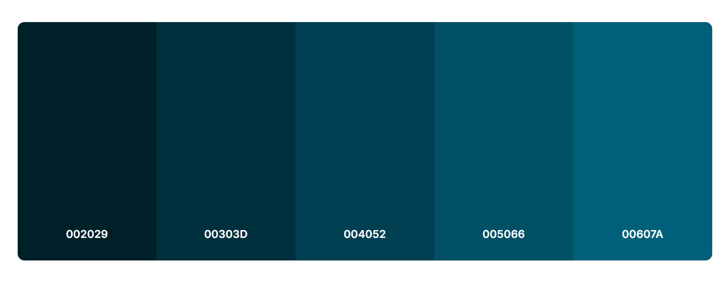

1. Pictures: pictures that suits the situation (like the cat pic in my about page)
2. Fonts:



